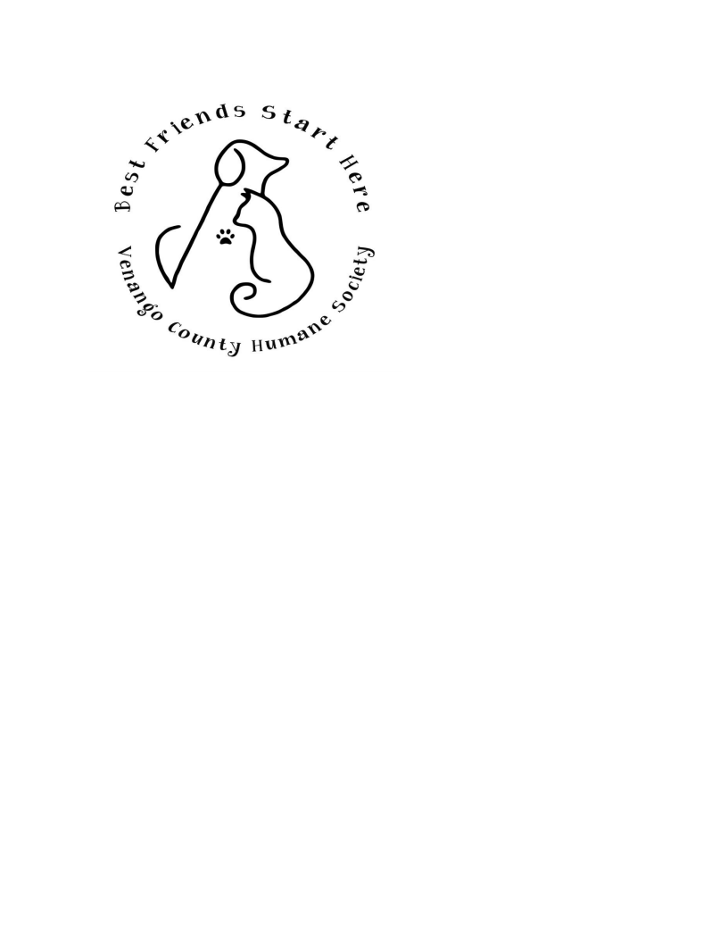

Social Media Policy

The Shelter Pets at the Venango County Humane Society
are a PROTECTED POPULATION

Therefore, no volunteer, community member or any other
person, who is not authorized, can photograph, text, Twitter
or place on Instagram any Shelter Pet without permission.

I agree not to photograph, text any information or images,
place on Twitter or Instagram, any Shelter Pets from the
Venango County Humane Society.

Name: __________________________________
Date: ___________________________________

Thank you for your cooperation!

